**Documentation on data types In JavaScript**

**Data types in JavaScript:**

**Data types:**

* Data types are values stored in variables to inform the Interpreter of what type of data we are handling.
* There are two types of data types:
* Primitive data types.
* Non-primitive data types.

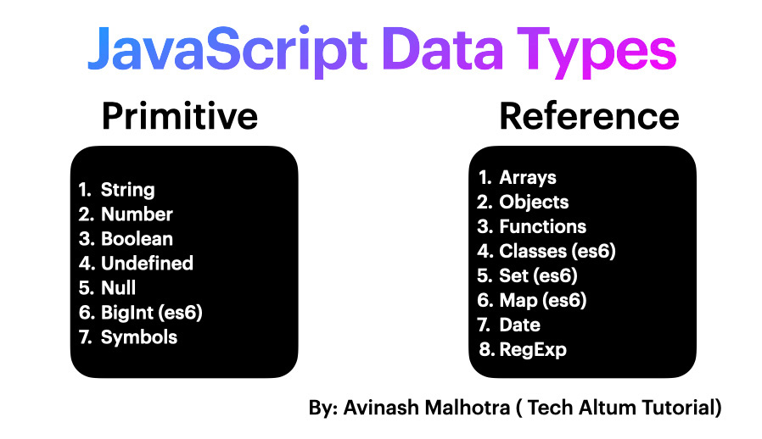

**Primitive and non-primitive types:**

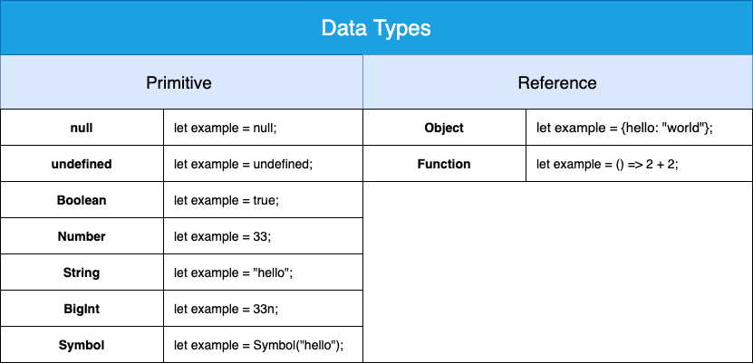

* **Primitive data types:**

Primitive data types are the most basic types of data that represent a simple value, they are immutable, meaning once a value, is assigned it can not be changed.

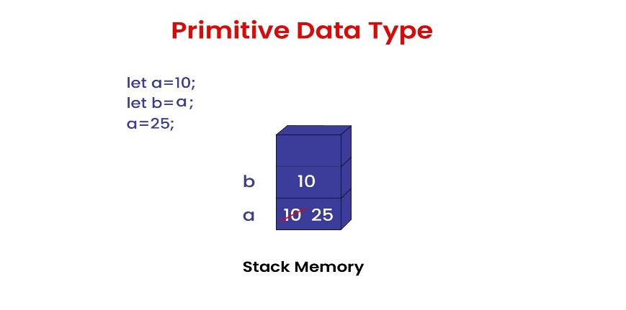

1. **Number:**

Number data type in Javascript can be used to hold decimal values as well as values without decimals.

**Example:**

var x = 250;

var y = 40.5;

console.log("Value of x=" + x);

console.log("Value of y=" + y);

**output:**

Value of x=250

Value of y=40.5

1. **Boolean:**

The Boolean data type can accept only two values there are true and false.

**Example:**

var x;

console.log(x); // Outputs: undefined

1. **Undefined:**

This means that a variable has been declared but has not been assigned a value, or it has been explicitly set to the value ‘undefined’.

**Example:**

let x;

console.log(x); // Outputs: undefined

**output:**

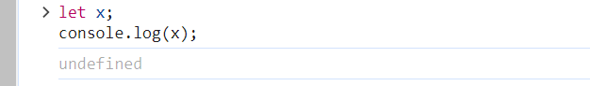

1. **String:**

The string data type in JavScript represents a sequences of characters that are surrounded by single or double quotes.

**Example:**

Var str = 'Hello All';

var str1 = "Welcome to my new house";

console.log("Value of str=" + str);

console.log("Value of str1=" + str1);

**output:**

Value of str=Hello All

Value of str1=Welcome to my new house

1. **BigInt:**

BigInt data type can represent numbers greater than 254 -1 which helps to perform operations on large numbers. The numbers especially by writing ‘n’ at the end of the value.

**Example:**

var a = 123422222222222222222222222222222222222n

console.log(a)

**output:**

123422222222222222222222222222222222222n

1. **Null:**

This data type can hold only one possible value that is null.

**Example:**

var x = null;

console.log("Value of x=" + x);

**output:**

Value of x=null

1. **Symbol:**

Symbol data type is used to create objects which will always be unique. These objects can be created using symbol constructor.

**Example:**

var sym = Symbol("Hello")

console.log(typeof(sym));

console.log(sym);

**output:**

symbol

Symbol(Hello)

* **Non-primitive data types:**

Non-primitive data types represent more complex structures and can hold values or more complex data collections. They are mutable, meaning their contents can be changed.